My Personal Land Recognition

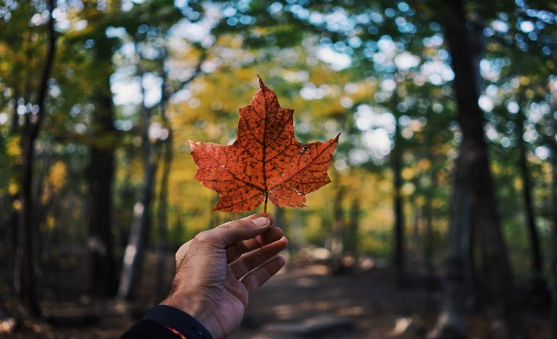

What is/are the name(s) of the Indigenous people’s whose land you are resting on?
(for assistance you can check-out the Native-Land.ca map found here in English and French: https://native-land.ca/?lang=fr, https://native-land.ca/ and English only here: http://squamishatlas.com / and English only here: https://www.whose.land/en/ )

What Indigenous language(s) are spoken on these lands?

Is this territory ceded or unceded?

What treaties (if any) are applicable to the territory you are resting on?

What is your relationship to the land you are on?

What do you know about the history of these Indigenous peoples and their early interaction with colonizers and settlers?

What current issues of are utmost importance to the Indigenous peoples whose territory you rest on?

What, if anything, are they asking of co-resisters, for support and solidarity?

What more can you do to learn more about, and/or build (better) relationships with, Indigenous peoples in the territory where you reside?

