Anti-Racism
A Trauma-Informed Approach to Facilitation

“When we educate for racial justice, we must engage in self-work and understand our power and privilege so that we do not harm our students through an inadvertent abuse of power. If we do nothing, Black (and Indigenous) people will continue to experience the injustices we have always faced.”

Dena Simmons: a lifelong learner, educator, and activist who supports schools throughout the US in implementing social and emotional learning and culturally responsive and equitable practices.

WHAT IS TRAUMA:

Racial trauma comprises the mental and physical effects and consequences that Black, Indigenous and people of colour experience after being exposed to racism.

It does not only occur when a person directly experiences racism; it is also a vicarious phenomenon that can be passed through generations. By being exposed to videos of police brutality or clips of racist encounters on social media and on the news, people are forced to live vicariously through instances of racism and discrimination. It’s inescapable. And for sufferers of racial trauma, the constant re-exposure to racism results in additional levels of stress and unexpected exposure to triggers.

BACKGROUND & RESEARCH

Most of the research on a trauma-informed approach to anti-racism education is geared to teaching children in classrooms and relies on long-term relationship building in circumstances where the educator and learners are together for long periods of time. While this does not reflect the learning environment we offer, there seems to be agreement on some core practices, whether it be children’s education, or adult education.

The good news, is that Popular Education, inherently incorporates many of these methods and ideologies, into its practices.

KEEP IN MIND

Our trauma work must include not only addressing the toxic stress of racism, which we know contributes to adverse mental and physical health effects of racialized people, but also confronting the dangers of white privilege. Acknowledging the impact of trauma on learning is of great importance if we want to create more socially just education and not disadvantage traumatized learners.

Trauma-Informed Facilitation - Core Elements

a) Some participants in the classroom may be traumatized,
b) Some content and assignments may have potential to re-traumatize,
c) Facilitator and participant behavior are potentially re-traumatizing,
d) The learning space may be unhelpful for traumatized learners,
e) Self-care for both facilitators and participants is important.

Socio-Interpersonal Factors That Can Help or Hinder Trauma Recovery.

Safety

- Survivors of trauma feel existentially unsafe, and find the world profoundly and imminently dangerous.

- Educators can create a sense of emotional safety by being transparent and consistent in both the lesson content and their interactions. A risk-free space for participants to ask questions and make mistakes without fear of humiliation is essential. Supports like sharing content and vocabulary in advance of a session reduces their stress and makes learning easier.

- Treating participants like responsible adults, worthy of trust, plays an important role in emotional safety.

Social Support and Belonging

- Social support is a well-known protective factor against PTSD and other forms of mental distress. Facilitators should create cooperative rather than competitive learning environments and methodologies. Their role is to foster supportive relationships among participants and between participants and the facilitation and administrative team.

- In an online environment, it is important that that social support include considerations like ensuring Black, Indigenous and racialized participants are not alone in a group of non-racialized and/or Indigenous participants. Their sense of safety and level of engagement will increase, if they feel supported. As well, this will help to ensure they do not bear the burden of the anti-racism teaching, in that group.

Valuing of Identities

- Valuing participants’ ethnic, religious, and other identities adds to a sense of belonging and ease. The simple act of acknowledging and honouring the different languages in the room or displaying images that reflect diversity, or some other act of solidarity with racialized and Indigenous people can make a palpable difference to participants. Such gestures not only make participants feel welcome and valued; they take away the fear of rejection so that they are free to focus on learning.

Valuing of Knowledge and Abilities

- Closely linked to a valuing of identities is paying respect to the knowledge and abilities that participants bring to the session. Recovery from trauma requires “a culture of justice and human rights that afford survivors and their communities a sense of acknowledgement, dignity, respect and empowerment” (Silove, 2013, p. 243).

- Inexperienced or ineffective facilitators may make the mistake of ‘teaching’ first rather than eliciting what participants already know. This robs learners of the opportunity to contribute knowledge to their peers. Being silenced, patronized, and robbed of legitimacy as a person of knowledge is anathema to both mental health and learning, while low self-worth has been correlated with more severe post-traumatic stress responses. Especially egregious is when facilitators presume to ‘teach’ participants about their own culture or country.

DO’S & DON’TS FOR NON-BLACK/Indigenous INDIVIDUALS

Do:

1. Acknowledge and call out the pain caused by racist beliefs and actions

2. Center Black and Indigenous voices without placing the burden on these individuals to lead conversations about race

3. Listen to the voices of those most impacted

4. Risk personal discomfort to engage in dialogue if you are not a member Black or Indigenous communities.

5. Convey openness to listening and deepening your understanding about others experiences and the effects, with no expectation that they take you up on it

6. Take responsibility for your own education and examine your understanding of the intersections of race, class and gender

Don’t:

1. Remain silent in the face of injustice

2. Be defensive

3. Expect Black or Indigenous individuals or to educate you or others. This is potentially re-traumatizing

4. Participate in performative ally ship (activism done to increase one's social capital rather than because of one's devotion to a cause)

5. Share viral recordings of Black or Indigenous individuals being brutalized or harmed

6. Assume that every Black or Indigenous person is impacted in the same way or needs the same kind of support

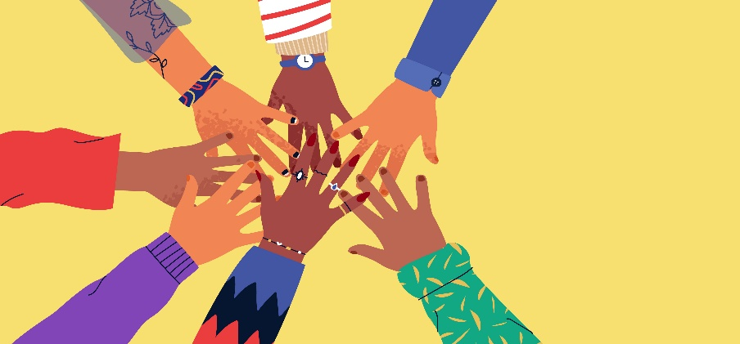

Added to include Indigenous peoples for relevance to our circumstances
https://www.huffingtonpost.ca/entry/what-racial-trauma-does-body-brain_l_5efa43b1c5b6acab28459220
Trauma Informed Teaching of Adults by Victoria Wilson (adapted for our circumstances)
Carello and Butler (2015)
Adkins, Birman, Sample, Brod, & Silver, 1998; Finn, 2010; Perry, 2006; Silove, 2013; van der Kolk, 2014
https://girlsinc.org/trauma-informed-approach-responding-racial-injustice/

